Aim: - Configuration of Simple Firewall using Cisco Packet Tracer.

Software Required: -

Cisco Packet Tracer 8.2.0

Procedure and Outputs: -

Step 1: - Make Topology

Select RS32 port and while clicking on PC2 with wire sign and then on server click console.

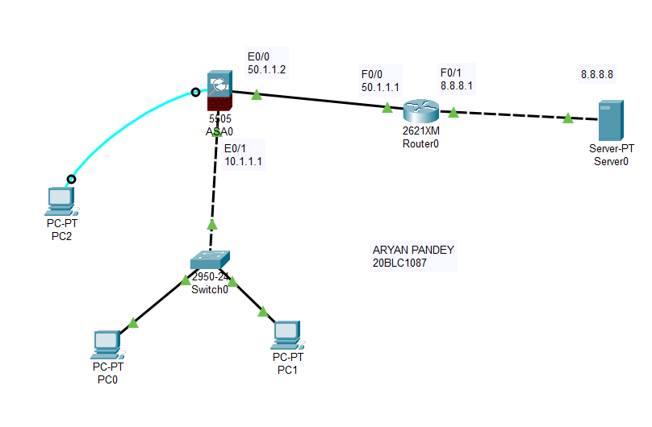

Step 2&3: - Assign IP accordingly on ASA & ISP Router and Set Inside and Outside on ASA Firewall.

Double click on PC2, click on desktop, then on terminal,

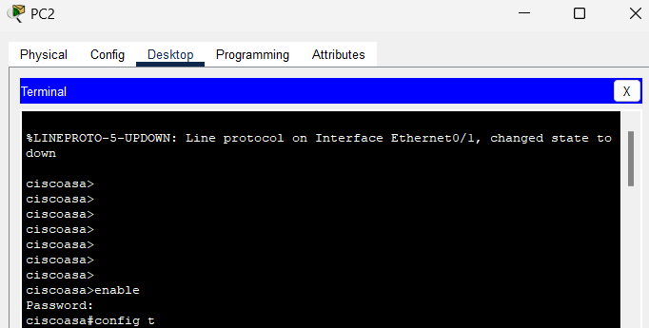

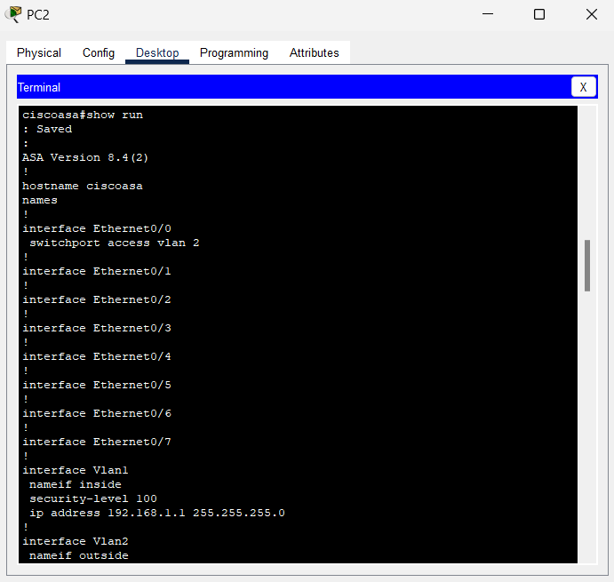

After entering “show run” command keep pressing enter button till the time “ciscoasa#” comes back

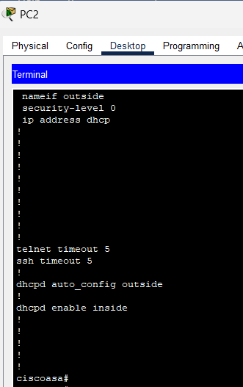

No DHCPD address because it wasn’t set up

If dhcpd address comes use command

“no dhcpd address 192.168.1.5 – 252.163.1.35 inside”

But first again go inside “config t” and then type above command.

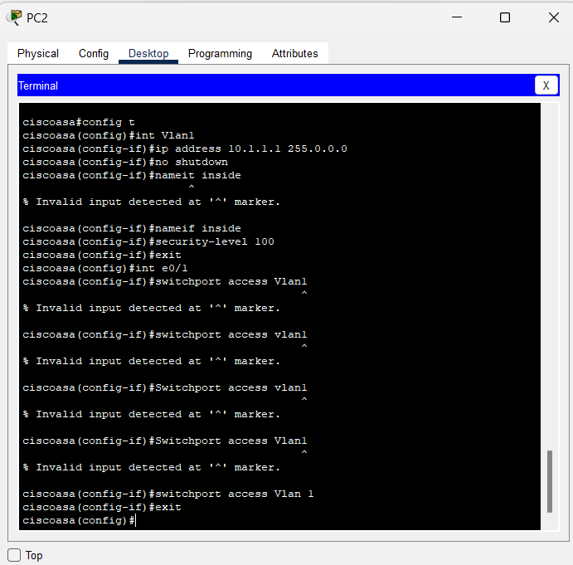

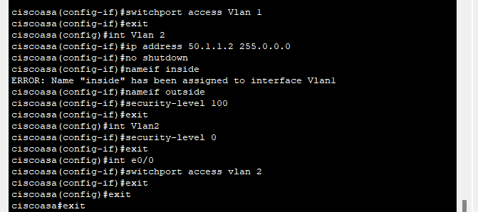

Then double click on the router next, then desktop, then terminal.

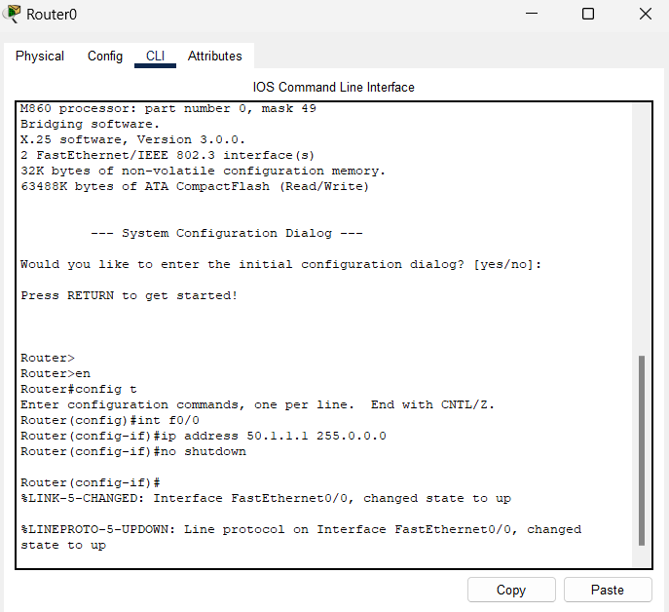

Then click on server button go to desktop and open IP configuration and fill the fields

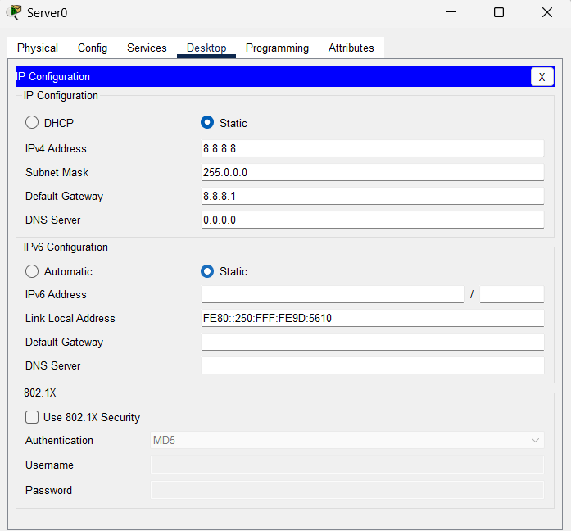

Step 4: - Configure DHCP Server and DNS IP on ASA

Then click on the ASA server again and go to terminal and put these commands before these commands make sure that PC0 and PC1 IP are set to DHCP instead of Static: -

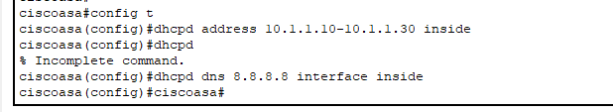

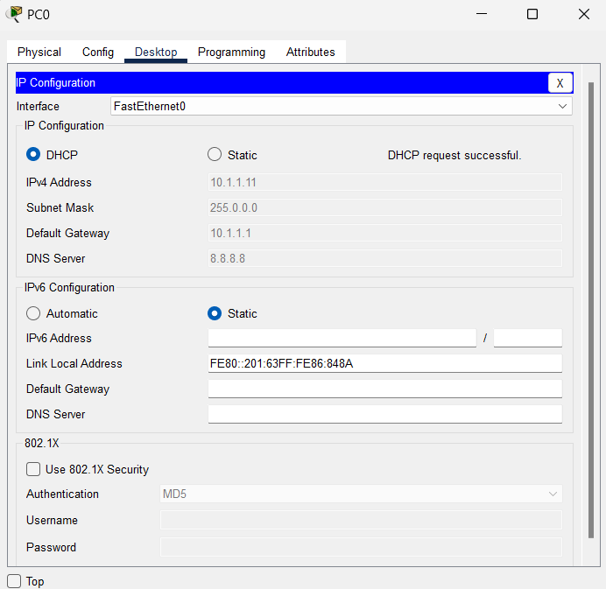

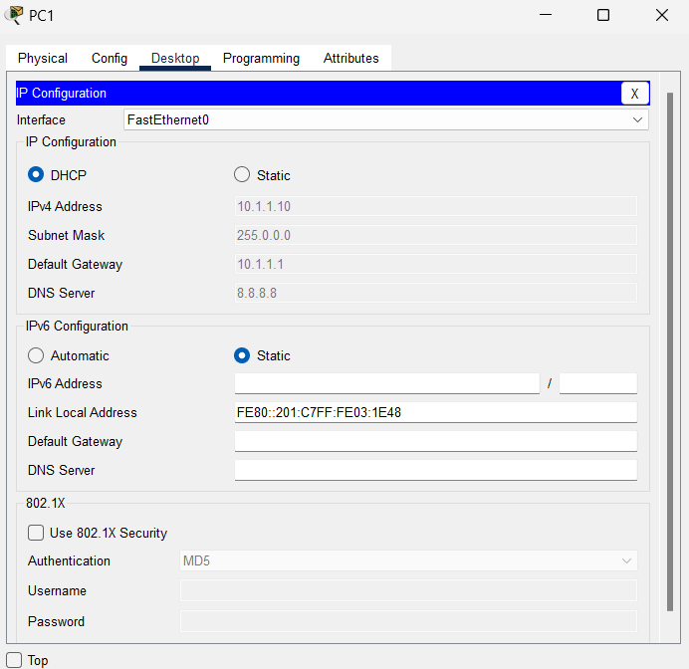

Step 5: - Configure Default Route on ASA

Configuring default route on ASA

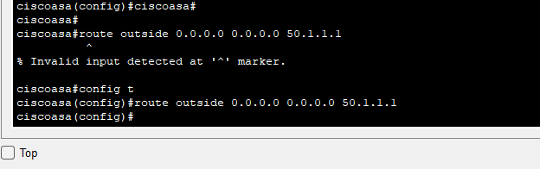

Step 6: - Configure OSPF on ISP Router

Configure OSPF on ISP router: -

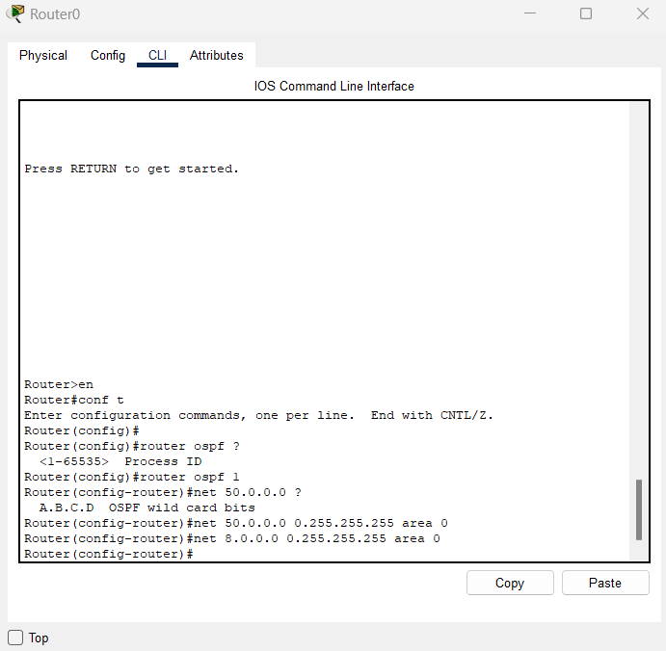

Step 7: - Create Object Network & Enable NAT on ASA

Create Object Network & Enable NAT on ASA: -

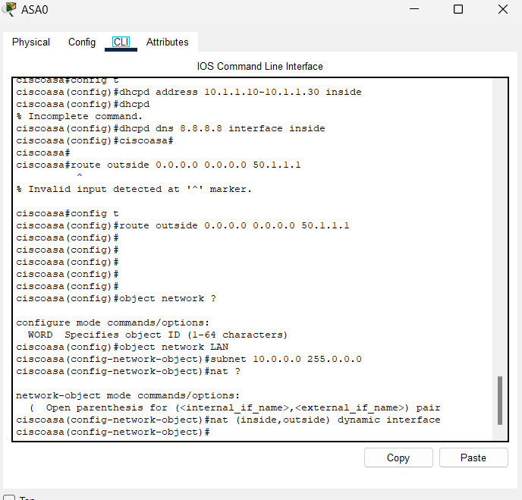

Step 8: - Create ACL on ASA

Create ACL on ASA: -

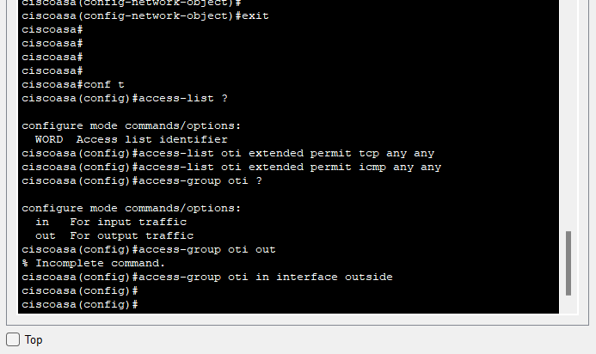

Step 9: - Verify

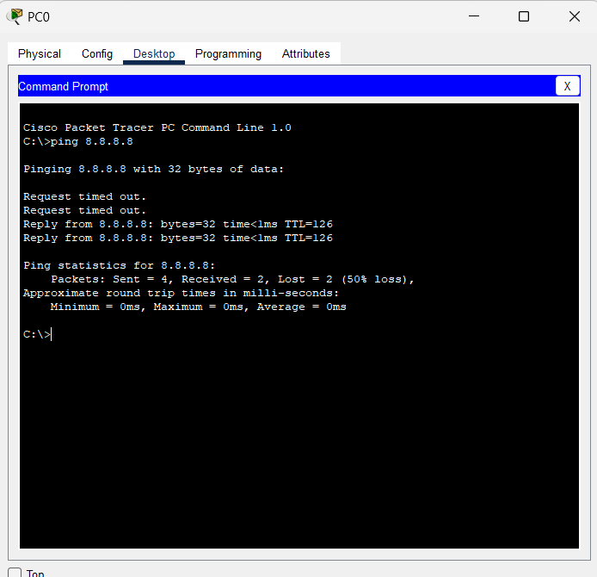

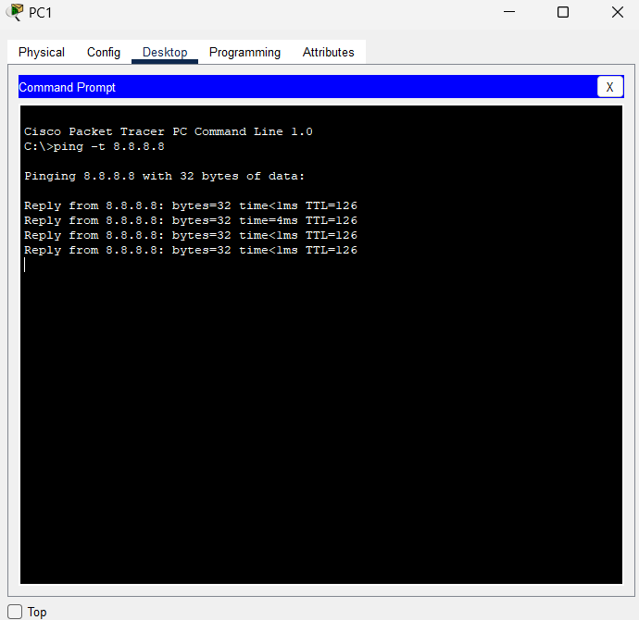

Packet Transferring: -

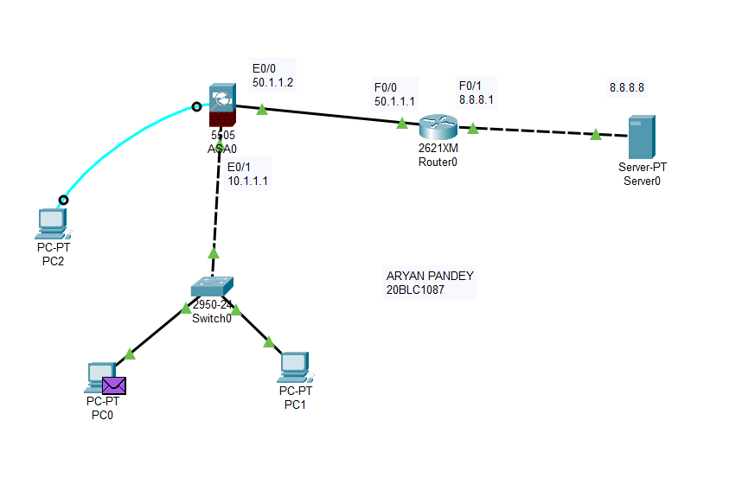

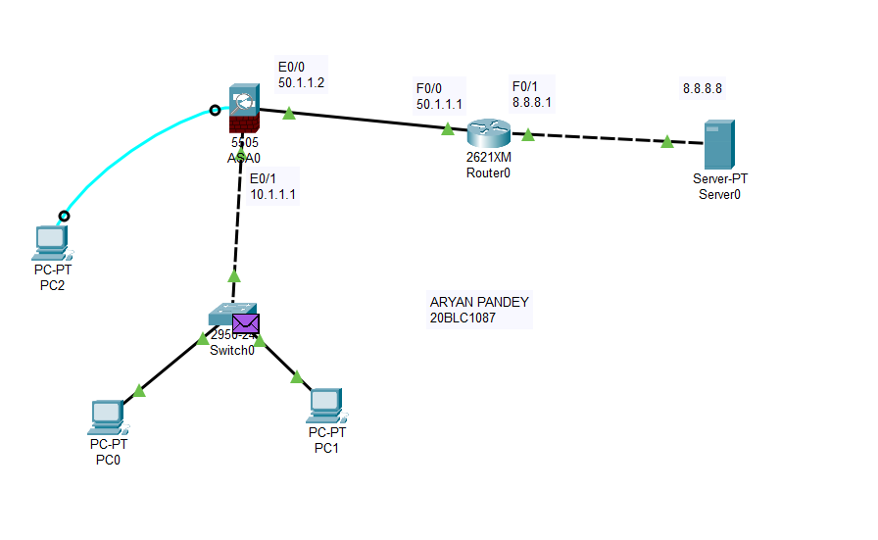

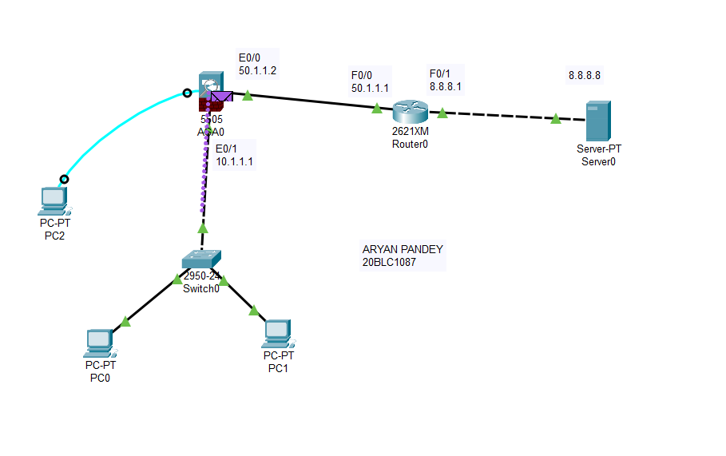

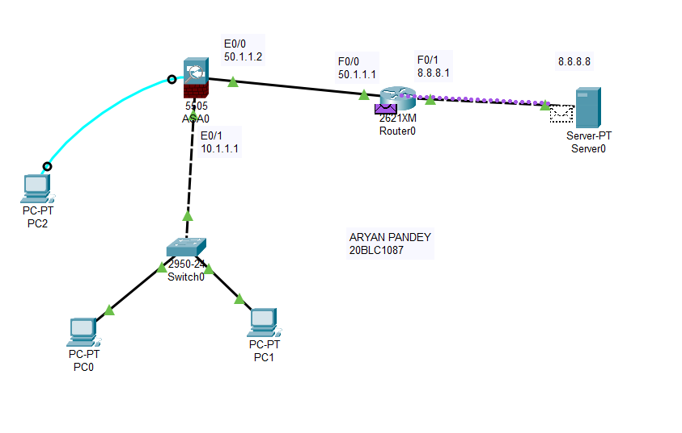

Returning Packet: -

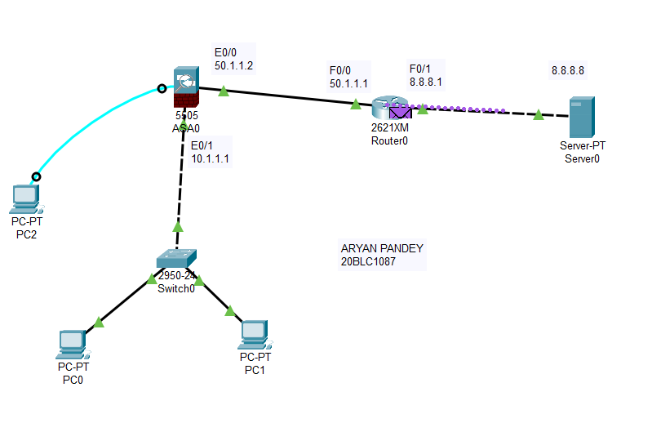

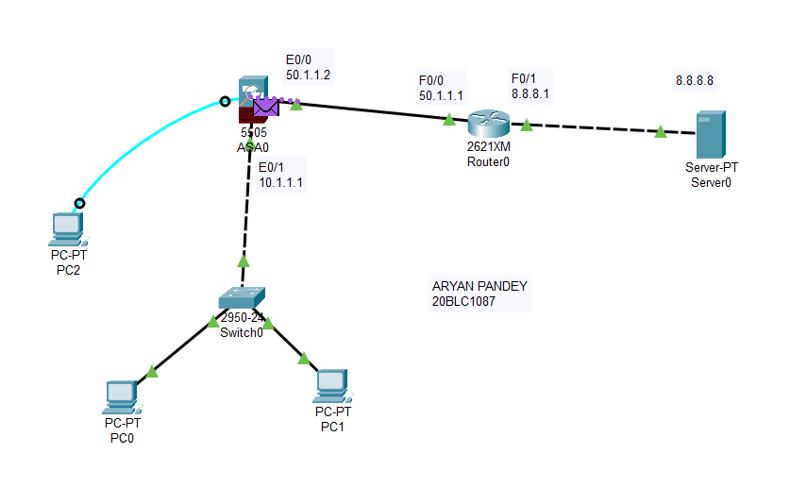

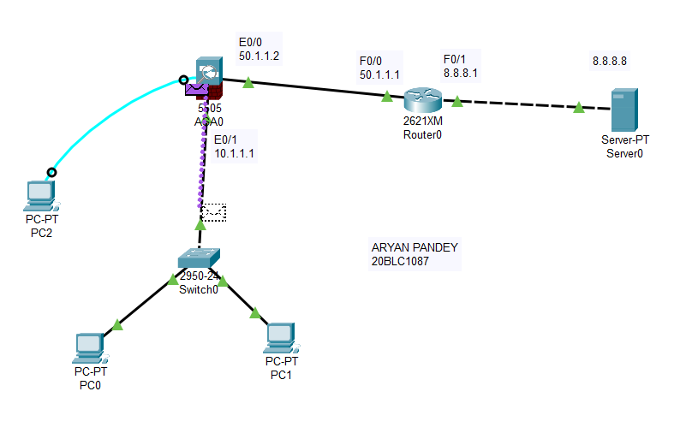

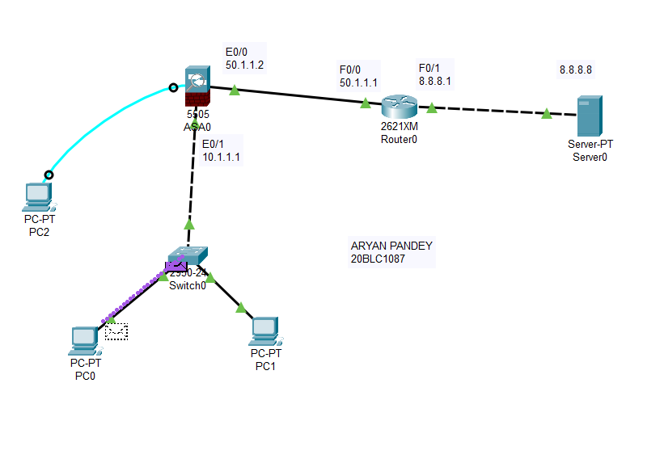

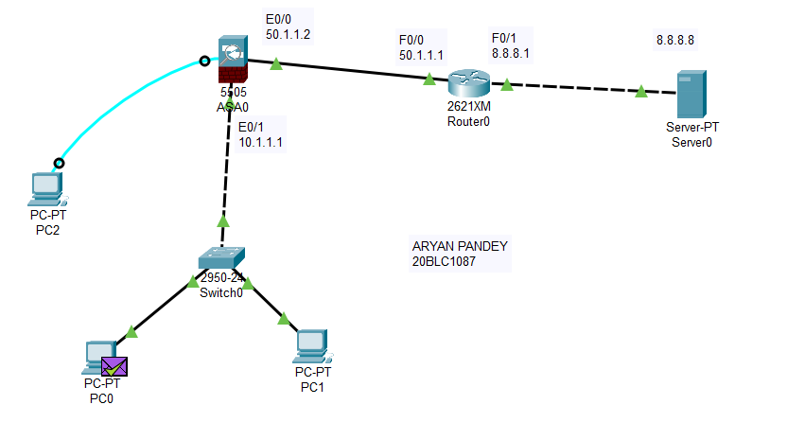

Result: -

Configuration of three routers using Cisco Packet Tracer.